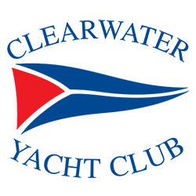

Membership Overview
Membership Type | Initiation Fee | Monthly Dues | Monthly F&B Minimum | Limitations
Full | $6,000 | $260* | ---
Social | $5,000 | $220* | --- | See reverse side
Junior | $1000 deposit  Balance due at age of 40 | $168* | --- | Open to applicants up to age 40.  Remainder of Initiation Fee Due at age 40
Active Military  First Responders | $500 | $168* | --- | Active Military, EMT’s, Police, and Firefighters up to age 40
Legacy | $250 | $168* | --- | For Children of Full Members up to age 40, Dues goes to that of Full Members.
*Capital Replacement  All Categories |  | $35.00 a month
Total Dues Amount

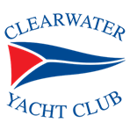

Membership Privileges & Amenities
Amenities | Full, Junior,  1st Responders,  Military & Legacy | Social
Use of restaurant and bar | ✓ | ✓
Use of tiki bar and dry-dock | ✓ | ✓
Use of pool deck | ✓ | ✓
Participate in events and parties | ✓ | ✓
Bring guests to the club | ✓ | ✓
Listing in the annual roster | ✓ | ✓
Book private parties | ✓ | ✓
Participate in CYC social clubs | ✓ | ✓
Serve on club committees | ✓ | ✓
Daily docking privileges | ✓ | ✓
Participate in waterfront activities | ✓ | ✓
Use of Sailing Center membership | ✓ | ✓
Wait list for slip at the club’s marina | ✓
Lease slip at the club’s marina | ✓
Overnight docking privileges | ✓
Full reciprocity with FCYC clubs | ✓
Voting rights | ✓
Advertise in the Compass | ✓

Subject to Florida sales tax at 7.0%.
Subject to Florida sales tax at 7.0%.
Subject to existing CYC guest policies and regulations.
Daily docking preference shall be given in the following order or preference: Full Members, Legacy, Junior Members 1ST Responders & Military, Social Members and Seasonal Members
Subject to the terms and conditions of any then-current CYC corporate membership in the Clearwater Community Sailing Center.
Subject to availability.

